Brew City 2015 Rule Change
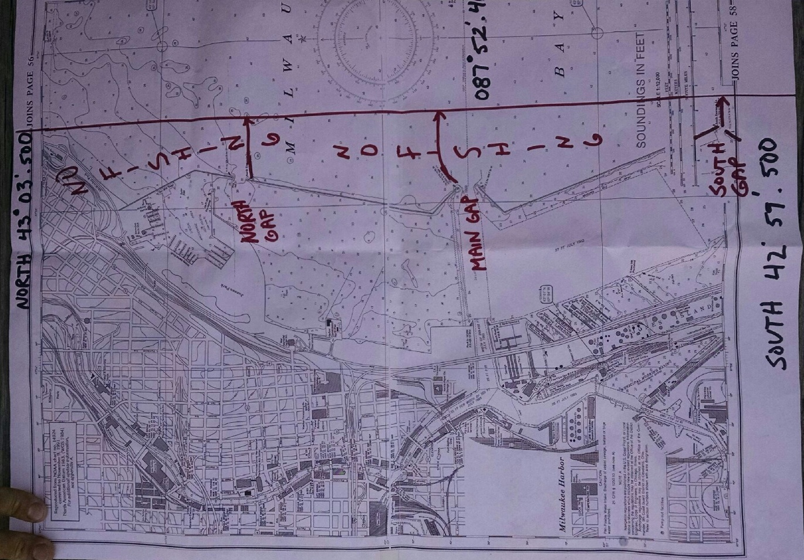
The no fishing area off the Milwaukee is N 43’03.500 North limit, N42’59.500 South limit and W087.52.400 is the East limit. No fishing at all in any harbor or harbor mouth. You must be at least 1/3 of a mile off any peir head or harbor on Lake Michigan. This is for safety reasons.
GLSF Rules Committee 7/30/15

